AWS PYTHON WEB APPLICATION DEPLOYMENT USING DOCKER AND AWS EC2

PROJECT TITLE

AWS Python Web Application Deployment Using Docker and AWS EC2
Technologies Used:
Python, Flask, Docker, GitHub, AWS EC2, AWS ECR
AWS Region:
ap-south-1 (Mumbai)
Submitted By:
Krishna Kumar
Project Type:
Cloud / DevOps Deployment Project
Date:
September 2026

ABSTRACT
This project demonstrates the development and deployment of a simple Python web application using Flask. The application is containerized using Docker and deployed on an AWS EC2 instance.
The source code is maintained in a GitHub repository. Docker is used to package the application and its dependencies into a portable container. The Docker container is then executed on an Ubuntu-based AWS EC2 instance.
The project also demonstrates the use of AWS Elastic Container Registry (ECR) for storing Docker images and provides a basic understanding of cloud-based application deployment.

INTRODUCTION
Cloud computing allows applications to be deployed and accessed over the internet without depending on local systems.
In this project, a simple Python Flask web application is developed and containerized using Docker. The source code is stored in GitHub, while AWS EC2 is used as the cloud server for running the Docker container.
The project demonstrates the complete flow:
Developer → GitHub → Docker → AWS EC2 → Web Application
The application provides a web page and REST API endpoints that can be accessed through a web browser

OBJECTIVES
The main objectives of this project are:
1. To develop a basic Python Flask web application.
2. To create a simple HTML frontend.
3. To create REST API endpoints using Flask.
4. To store the project source code in GitHub.
5. To create a Dockerfile for containerization.
6. To build a Docker image.
7. To run the application inside a Docker container.
8. To create and use an AWS EC2 instance.
9. To deploy the Docker container on EC2.
10. To understand AWS ECR for Docker image storage.
11. To access and test the application through the EC2 public IP address.

TECHNOLOGIES USED
Technology | Purpose
Python | Application development
Flask | Python web framework
HTML | Frontend development
JavaScript | API interaction
Docker | Application containerization
Git | Version control
GitHub | Source code repository
AWS EC2 | Cloud server
AWS ECR | Docker image registry
Ubuntu | EC2 operating system
PowerShell | Local command-line environment

SYSTEM ARCHITECTURE
The system architecture shows how the Python Flask application moves from local development to cloud deployment. The application is first developed and tested locally. It is then containerized using Docker and stored in GitHub. Finally, the Dockerized application is deployed on an AWS EC2 Ubuntu server.
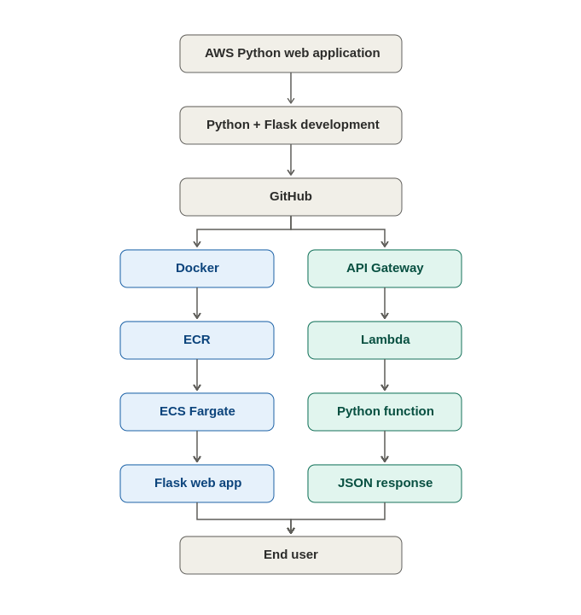

Architecture Explanation
The developer creates the Python Flask application and pushes the source code to GitHub.
The application is packaged into a Docker image using the Dockerfile. The Docker image can be stored in AWS ECR.
For deployment, the application is run inside a Docker container on an AWS EC2 Ubuntu server.
Users can access the application using:
http://EC2_PUBLIC_IP:5000

PROJECT STRUCTURE
The project contains the following files:
aws-python-webapp/
│
├── app.py
├── requirements.txt
├── Dockerfile
│
└── templates/
└── index.html

File Description
app.py
Contains the Flask application and API routes.
requirements.txt
Contains the Python dependencies required by the application.
Dockerfile
Contains instructions for creating the Docker image.
templates/index.html
Contains the frontend HTML page

4. Project Folder Structure
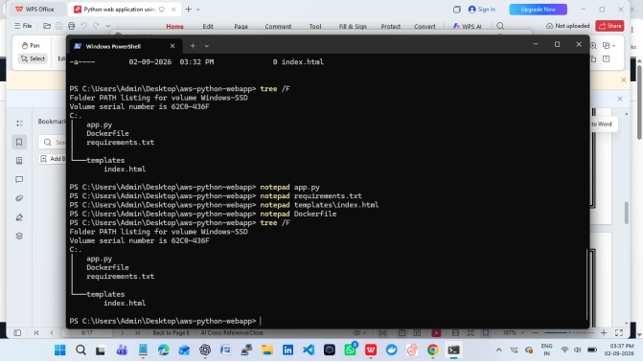

Create the Python Flask Application
Create the project folder and templates directory in PowerShell:
mkdir aws-python-webapp
cd aws-python-webapp
mkdir templates
Create app.py:
from flask import Flask, jsonify, render_template
app = Flask(__name__)
@app.route("/")
def home():
return render_template("index.html")
@app.route("/api/status")
def status():
return jsonify({
"message": "AWS Python Web App is running",
"application": "Python Flask Web App",
"status": "success"
})
if __name__ == "__main__":
app.run(host="0.0.0.0", port=5000)
Create requirements.txt:
Flask==3.1.2
Create templates/index.html:
<!DOCTYPE html>
<html>
<head>
<title>AWS Python Web App</title>
</head>
<body>
<h1>AWS Python Web App</h1>
<p>Application is running successfully.</p>
<p>Deployment: Python Flask</p>
</body>
</html>

Test the Application Locally
python -m venv venv
venv\Scripts\activate
pip install -r requirements.txt
python app.py
Open the browser: http://127.0.0.1:5000/
API test: http://127.0.0.1:5000/api/statusExpected API status: application = Python Flask Web App, status = success.
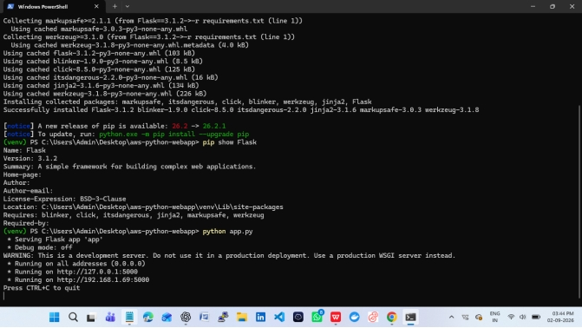
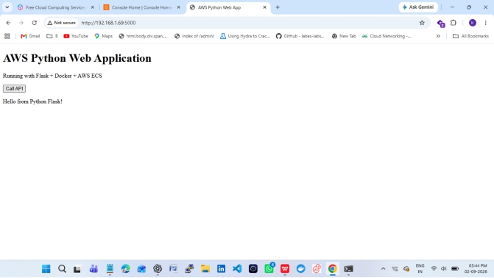

Configure AWS CLI
aws configure
aws sts get-caller-identity
Enter the AWS credentials, default region (ap-south-1), and output format (json) when prompted.
Security note: Never place AWS access keys, secret keys, passwords, or private keys in source code, Dockerfiles, GitHub, or screenshots.
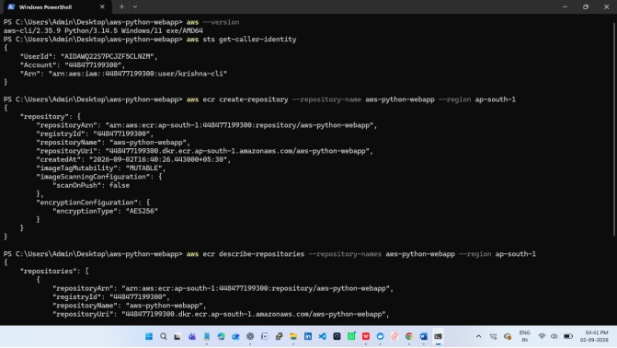

Launch an Ubuntu EC2 Instance
- Open AWS Console → EC2 → Instances → Launch instance.
- Name: aws-python-webapp-ec2.
- Choose an Ubuntu Server LTS AMI.
- Choose a small eligible instance type suitable for your account/budget.
- Create/select a key pair and download the .pem file.
- Security Group: SSH TCP 22 from your IP only.
- For direct Flask testing, allow TCP 5000 from your IP.
- Launch the instance and copy its public IPv4 address.
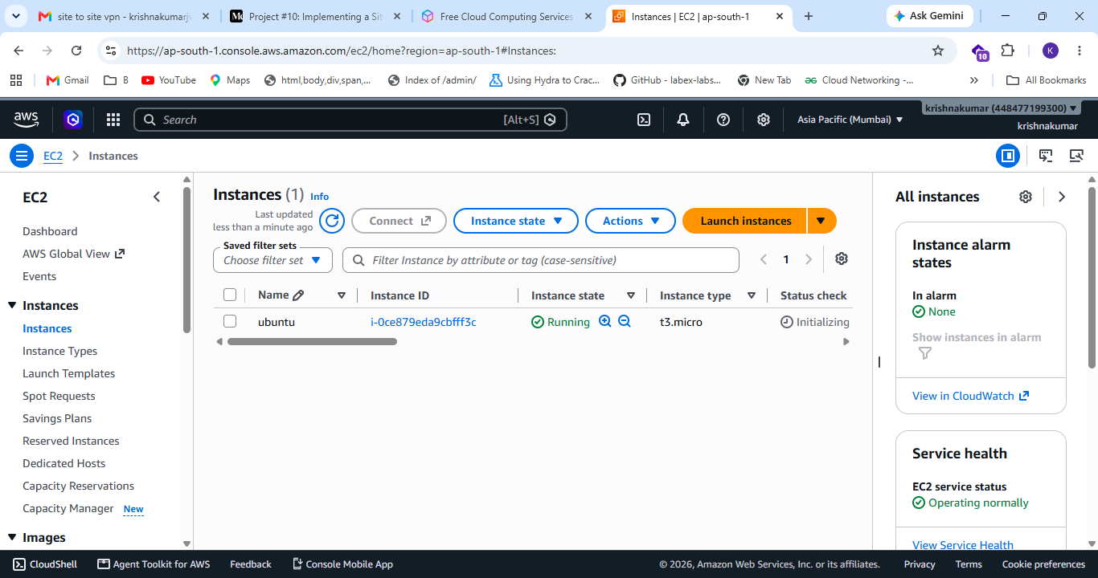

Install Python and Run the App on EC2
sudo apt update
sudo apt install -y python3 python3-venv python3-pip
mkdir -p ~/aws-python-webapp
cd ~/aws-python-webapp
Copy the project files to EC2 using Git, SCP, or another secure method. Then run:
python3 -m venv venv
source venv/bin/activate
pip install -r requirements.txt
python app.pyOpen: http://<EC2_PUBLIC_IP>:5000/
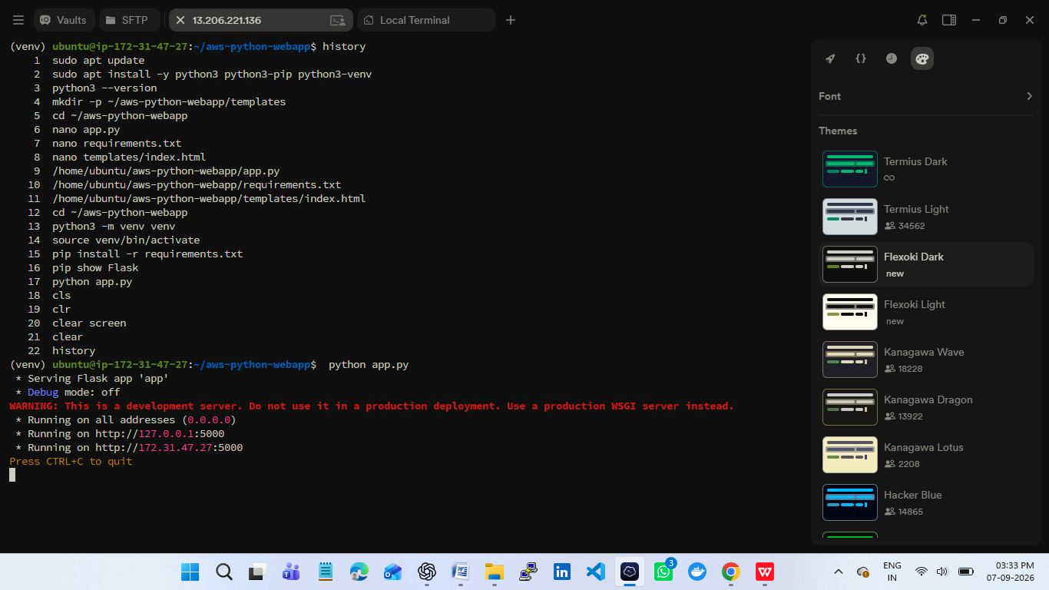
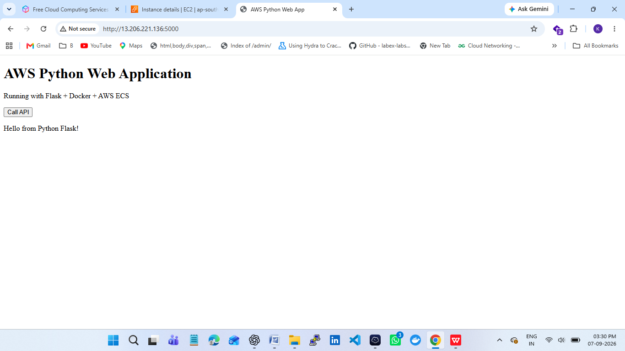

Create the Dockerfile
FROM python:3.12-slim
WORKDIR /app
COPY requirements.txt .
RUN pip install --no-cache-dir -r requirements.txt
COPY . .
EXPOSE 5000
CMD ["python", "app.py"]
Save the file exactly as Dockerfile with no .txt extension.
Build and Test the Docker Image
docker build -t aws-python-webapp .
docker images
docker run -d --name aws-python-webapp-container -p 5000:5000 aws-python-webapp
docker ps
Open: http://localhost:5000/
docker stop aws-python-webapp-container
docker rm aws-python-webapp-container
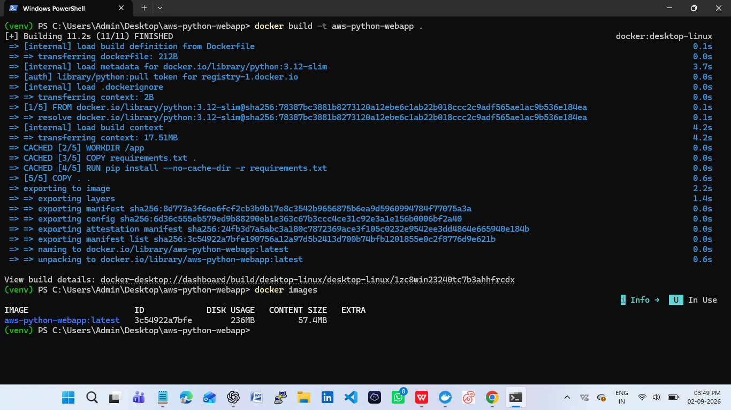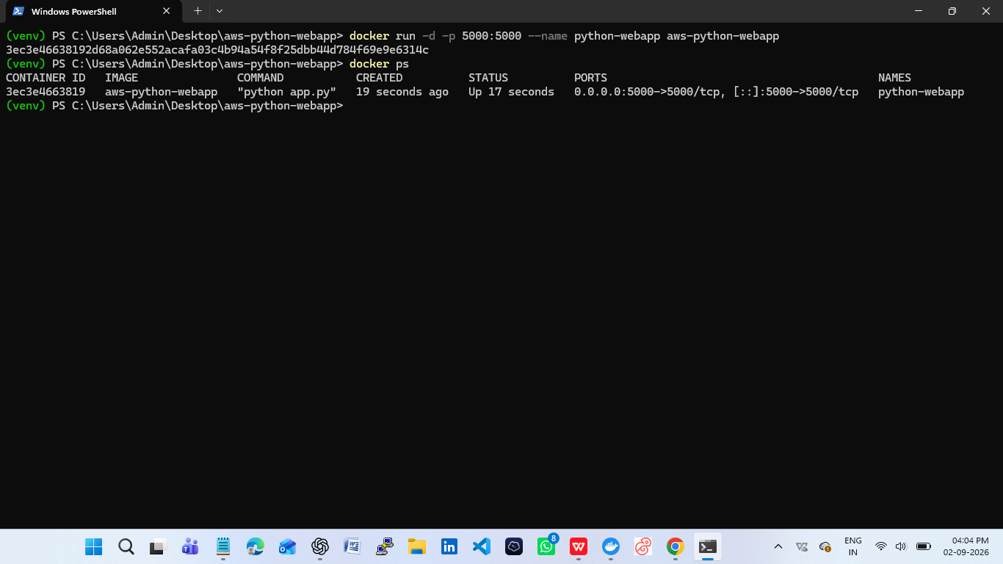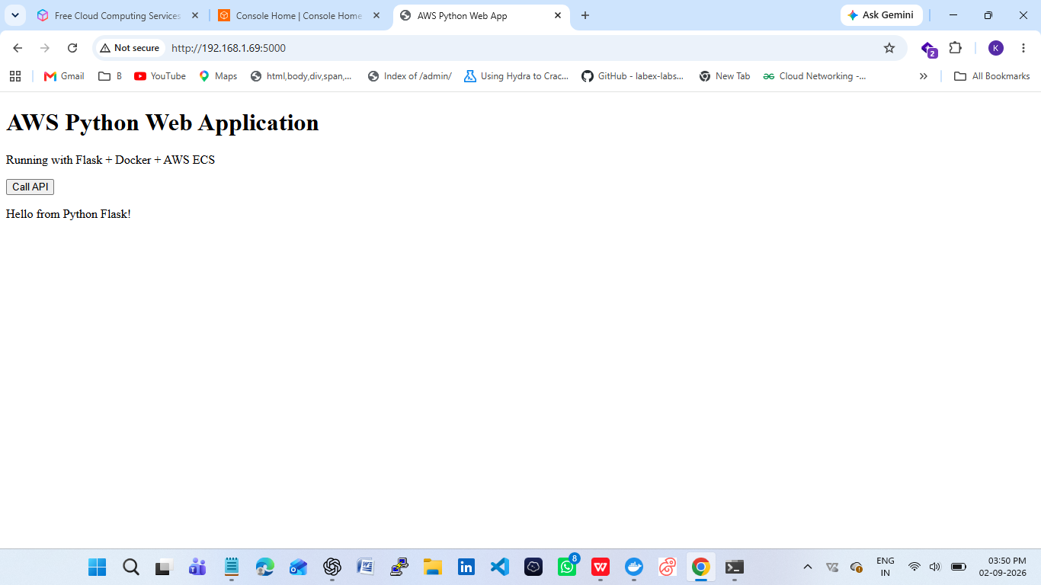

Create Amazon ECR Repository
AWS Console → ECR → Private repositories → Create repository.
Repository name: aws-python-webapp
Push Docker Image to ECR
aws ecr get-login-password --region ap-south-1 | docker login --username AWS --password-stdin <ACCOUNT_ID>.dkr.ecr.ap-south-1.amazonaws.com
docker tag aws-python-webapp:latest <ACCOUNT_ID>.dkr.ecr.ap-south-1.amazonaws.com/aws-python-webapp:latest
docker push <ACCOUNT_ID>.dkr.ecr.ap-south-1.amazonaws.com/aws-python-webapp:latest
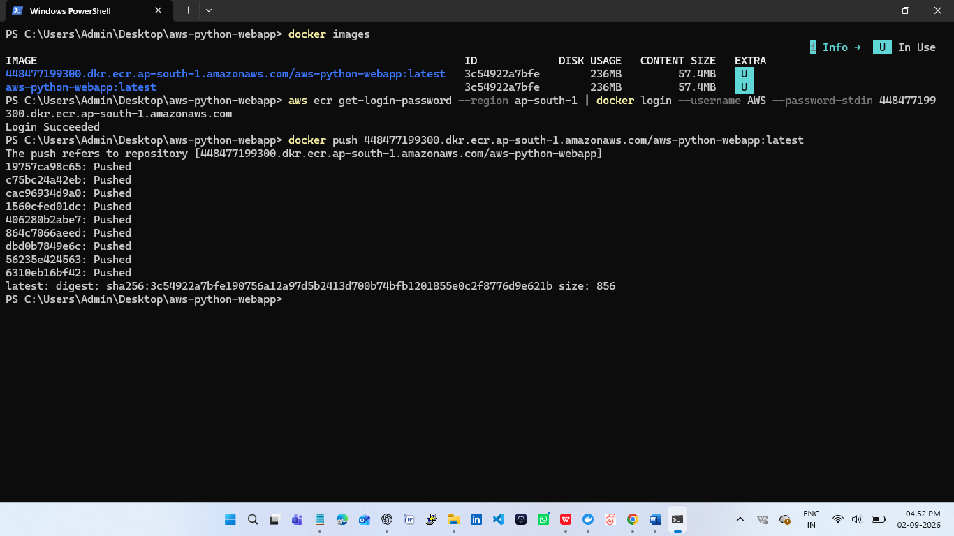

Create ECS Cluster
AWS Console → ECS → Clusters → Create cluster.
Cluster name: aws-python-webapp-cluster
Use ECS with AWS Fargate so the container can run without managing an ECS EC2 worker fleet.
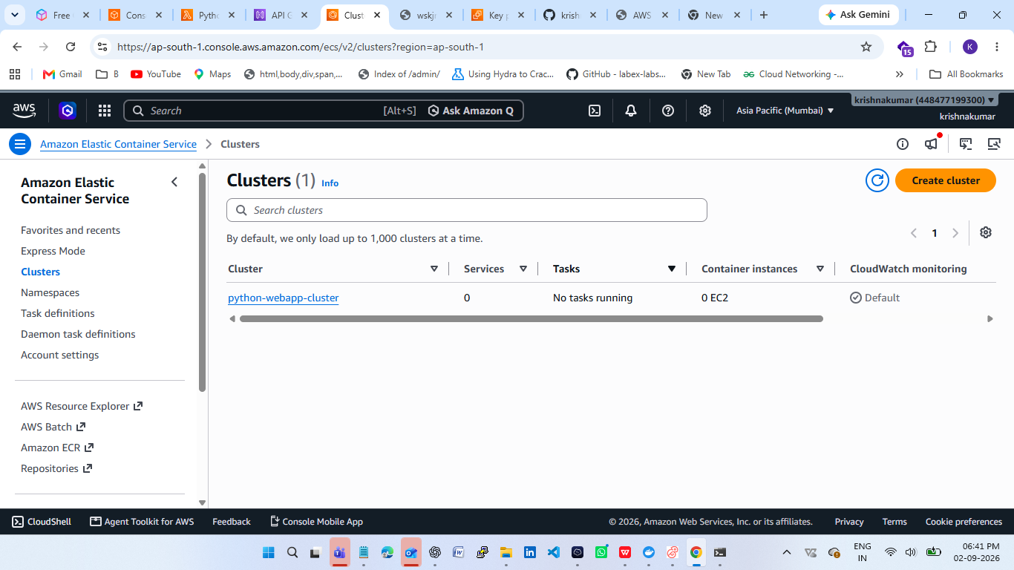
.

Create ECS Task Definition
- Family: aws-python-webapp-task.
- Compatibility: Fargate.
- CPU: 0.25 vCPU / 256 CPU units.
- Memory: 0.5 GB / 512 MiB.
- Task execution role: ECS task execution role with AmazonECSTaskExecutionRolePolicy.
- Container name: aws-python-webapp.
- Image URI: your ECR image URI ending in :latest.
- Container port: 5000 TCP.
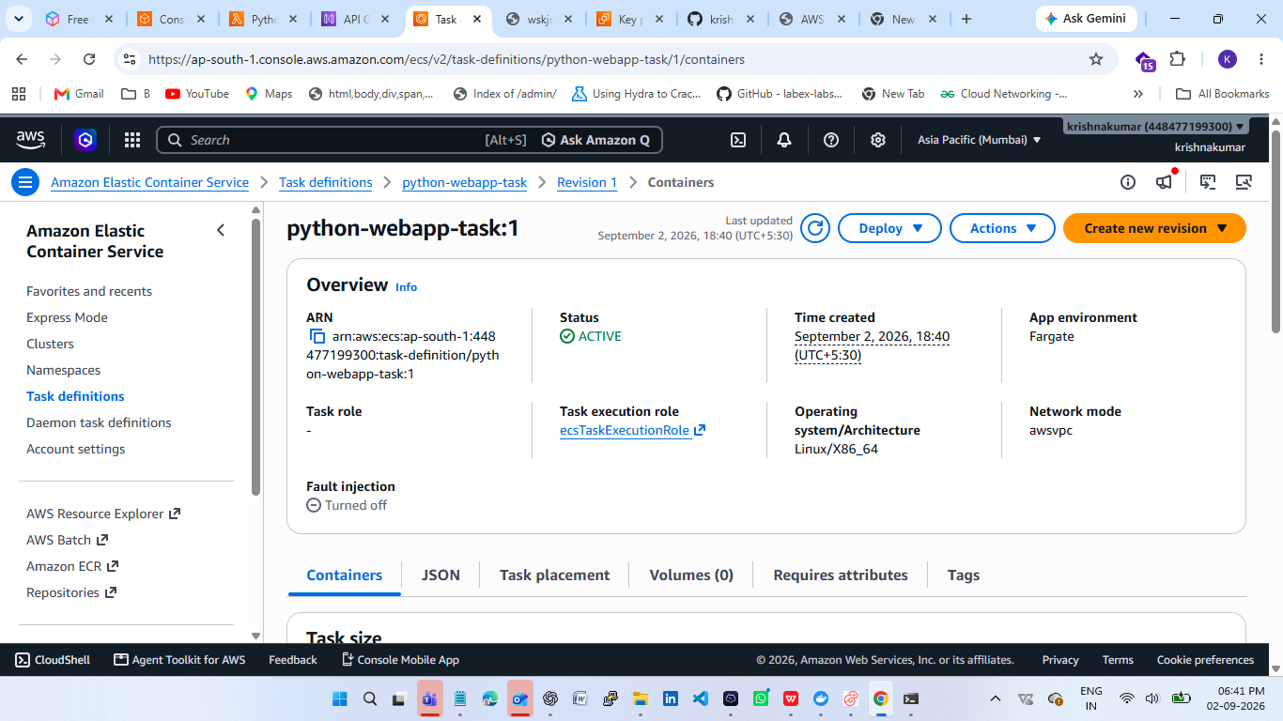

Create ECS Service
- Open ECS → Clusters → aws-python-webapp-cluster → Create service.
- Compute option: Fargate.
- Task definition: aws-python-webapp-task.
- Service name: aws-python-webapp-service.
- Desired tasks: 1.
- Select the VPC and public subnets.
- Allow TCP 5000 from your IP for learning/testing, or from a load balancer security group if an ALB is used.
- Enable public IP for direct testing without a load balancer.
- Create the service.
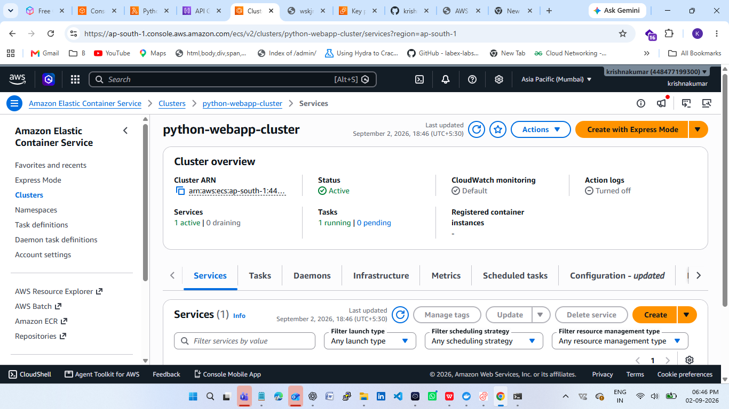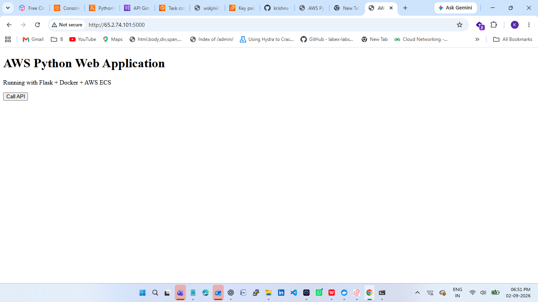
Lambda Function (Serverless Demonstration)
AWS Console → Lambda → Create function → Author from scratch.
Function name: aws-python-webapp-lambda. Choose a currently supported Python runtime.
import json
def lambda_handler(event, context):
return {
"statusCode": 200,
"headers": {
"Content-Type": "application/json"
},
"body": json.dumps({
"message": "Hello from AWS Lambda!",
"application": "Python Web App",
"status": "success"
})
}
Choose Deploy and test the function using the Lambda Test tab.
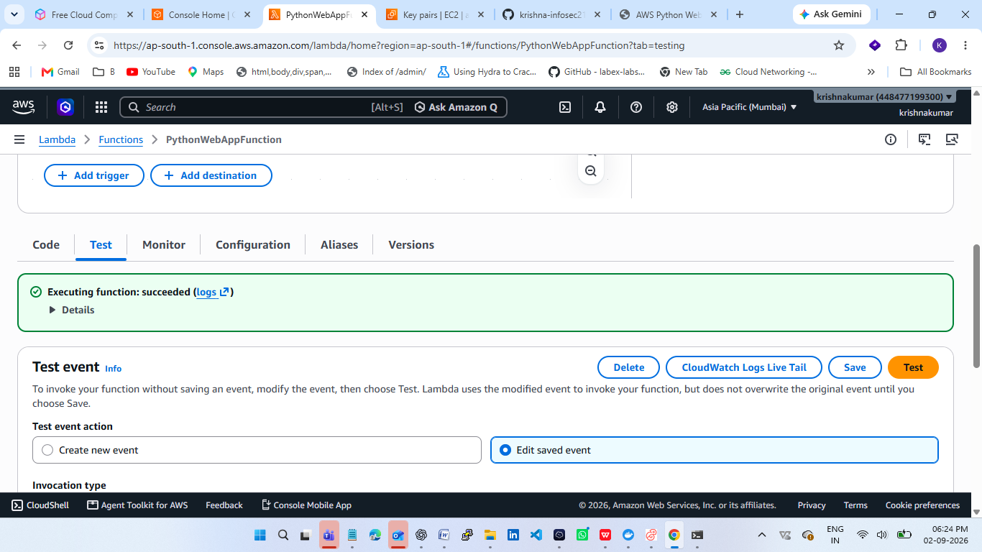

API Gateway HTTP API
- Open API Gateway → APIs → Create API.
- Under HTTP API, choose Build.
- Add Lambda integration and select aws-python-webapp-lambda.
- API name: aws-python-webapp-api.
- Route: GET /hello.
- Create the API and copy the Invoke URL.
Test: <API_INVOKE_URL>/hello
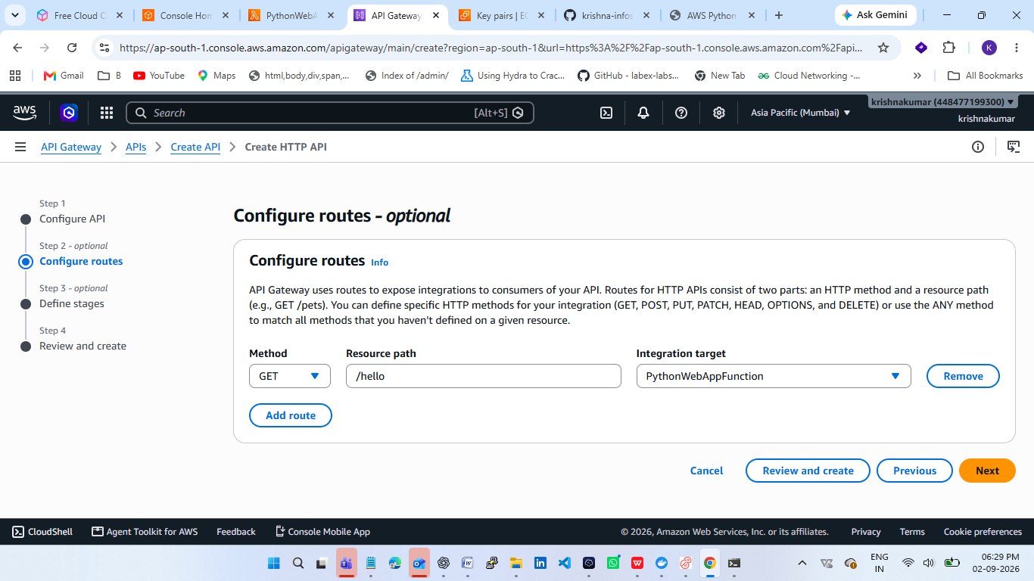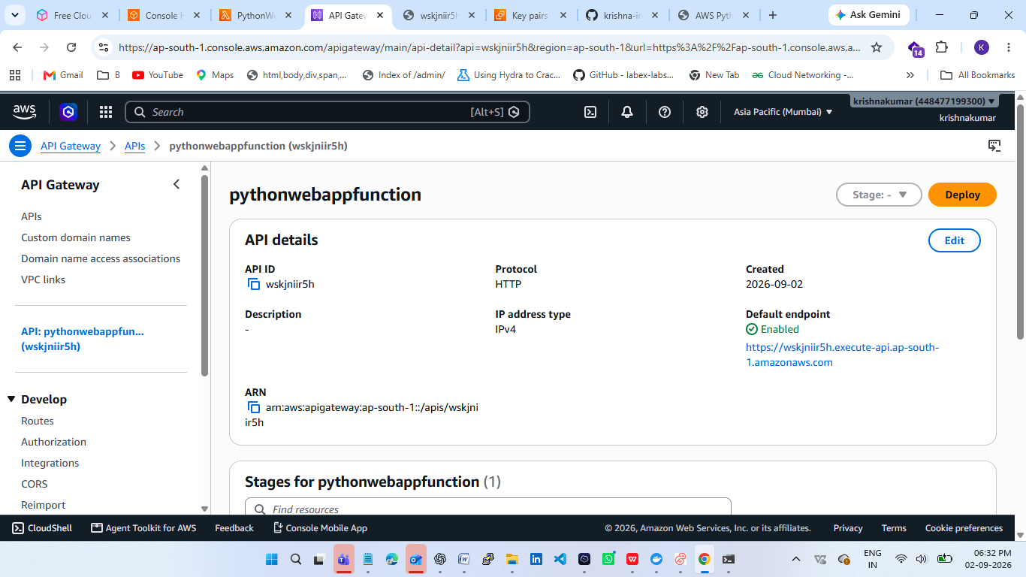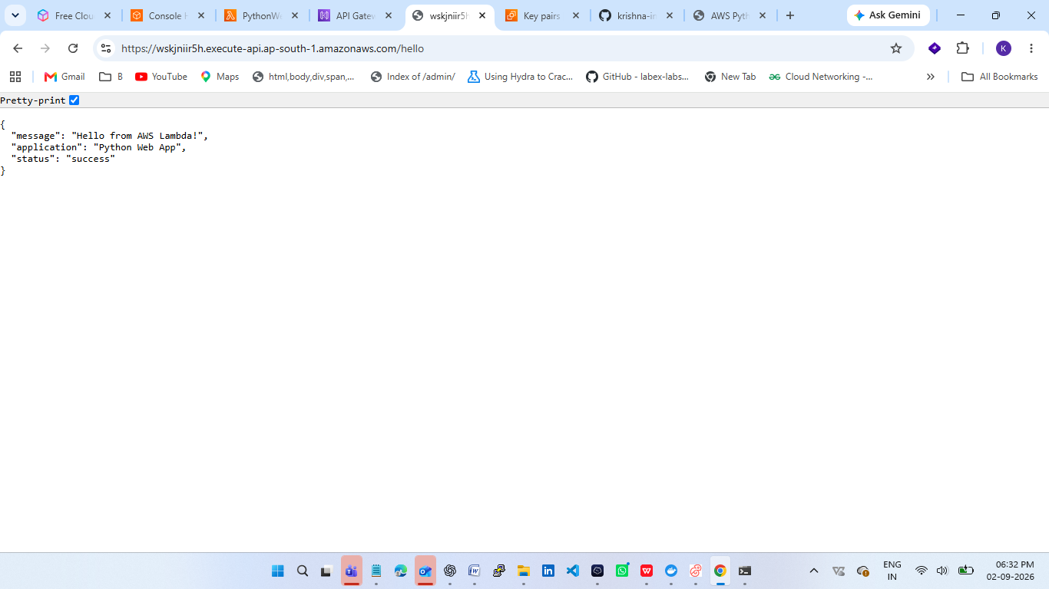

GitHub Repository Preparation

Project folder:

aws-python-webapp/
├── app.py
├── requirements.txt
├── Dockerfile
├── templates/
│ └── index.html
└── README.md

Initialize Git
git init
git add .
git commit -m "Initial AWS Python web application project"

Create GitHub Repository
GitHub → New Repository → Repository name: aws-python-webapp
Create repository.
Then EC2 terminal:
git branch -M main
git remote add origin https://github.com/YOUR_USERNAME/aws-python-webapp.git
git push -u origin main
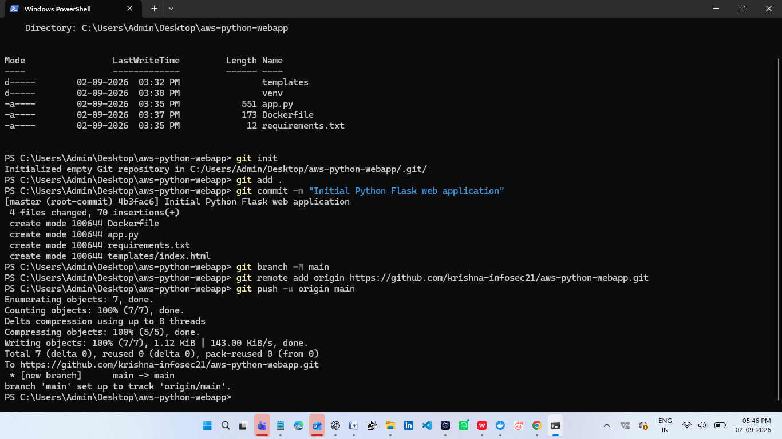
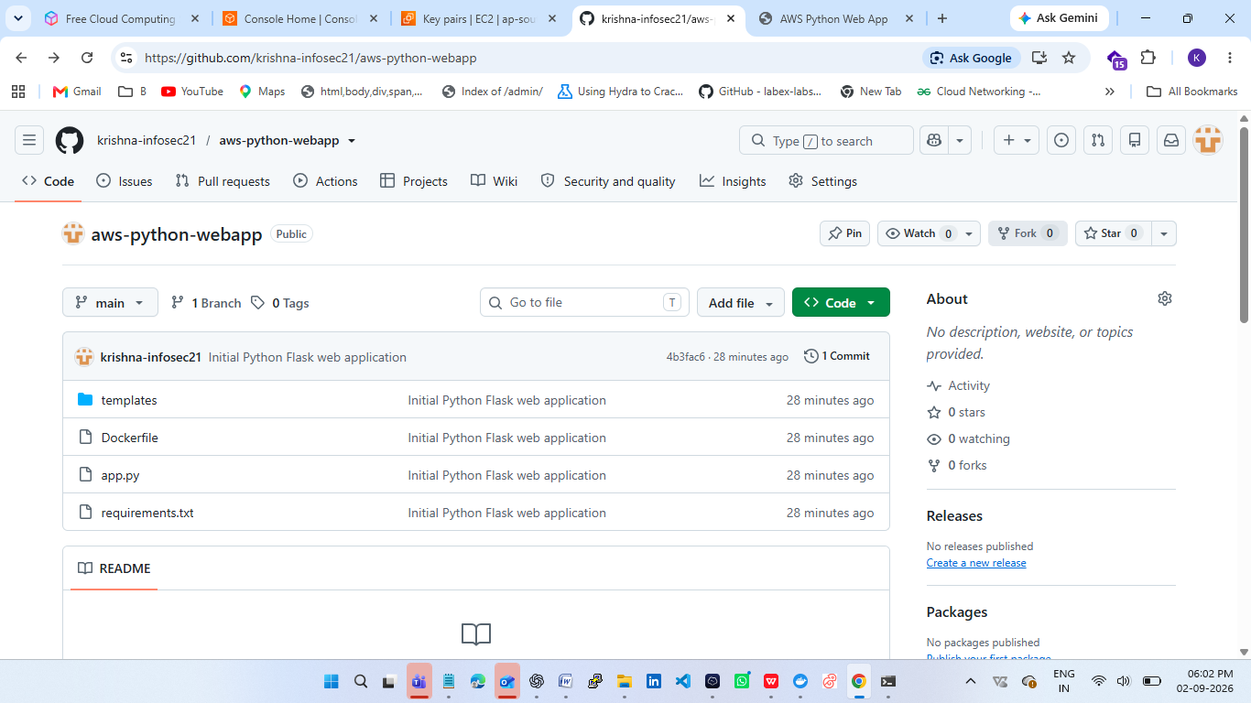

Testing Checklist
☐ Flask application works locally.
☐ Local /api/status returns success.
☐ EC2 deployment works.
☐ Docker image builds successfully.
☐ Docker container runs successfully.
☐ Docker image is available in ECR.
☐ ECS/Fargate service has one running task.
☐ ECS application response works.
☐ Lambda test returns HTTP 200.
☐ API Gateway GET /hello works.
☐ .gitignore is present.
☐ No AWS credentials, private keys, or secrets are in GitHub.
Project Outcome
The completed project demonstrates practical cloud deployment skills using Python Flask, Amazon EC2, Docker, Amazon ECR, Amazon ECS/Fargate, AWS Lambda, API Gateway,IAM and networking. The GitHub repository provides a reproducible source-code record, while this Word report provides the deployment procedure and screenshot evidence.

